IDEATION PHASE BRAINSTORM & IDEA PRIORITIZATION

|  |  |
| --- | --- |
| DATE | 22 November 2022 |
| TEAM ID | PNT2022TMID25156 |
| PROJECT NAME | STATISTICAL MACHINE LEARNING APPROACHES TO LIVER DISEASE PREDICTION |
| MAXIMUM MARK | 4 Marks |

**Brainstorm & Idea Prioritization:**

Step-1: Team Gathering, Collaboration and Select the Problem Statement

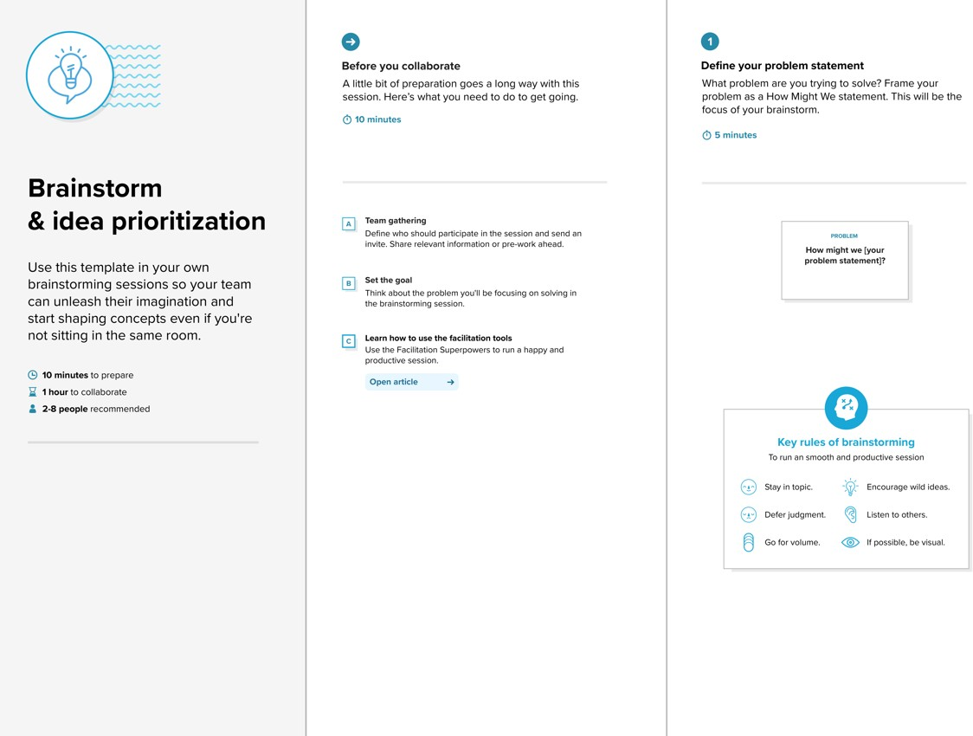

Step 2: Brainstorm, Idea Listing and Grouping

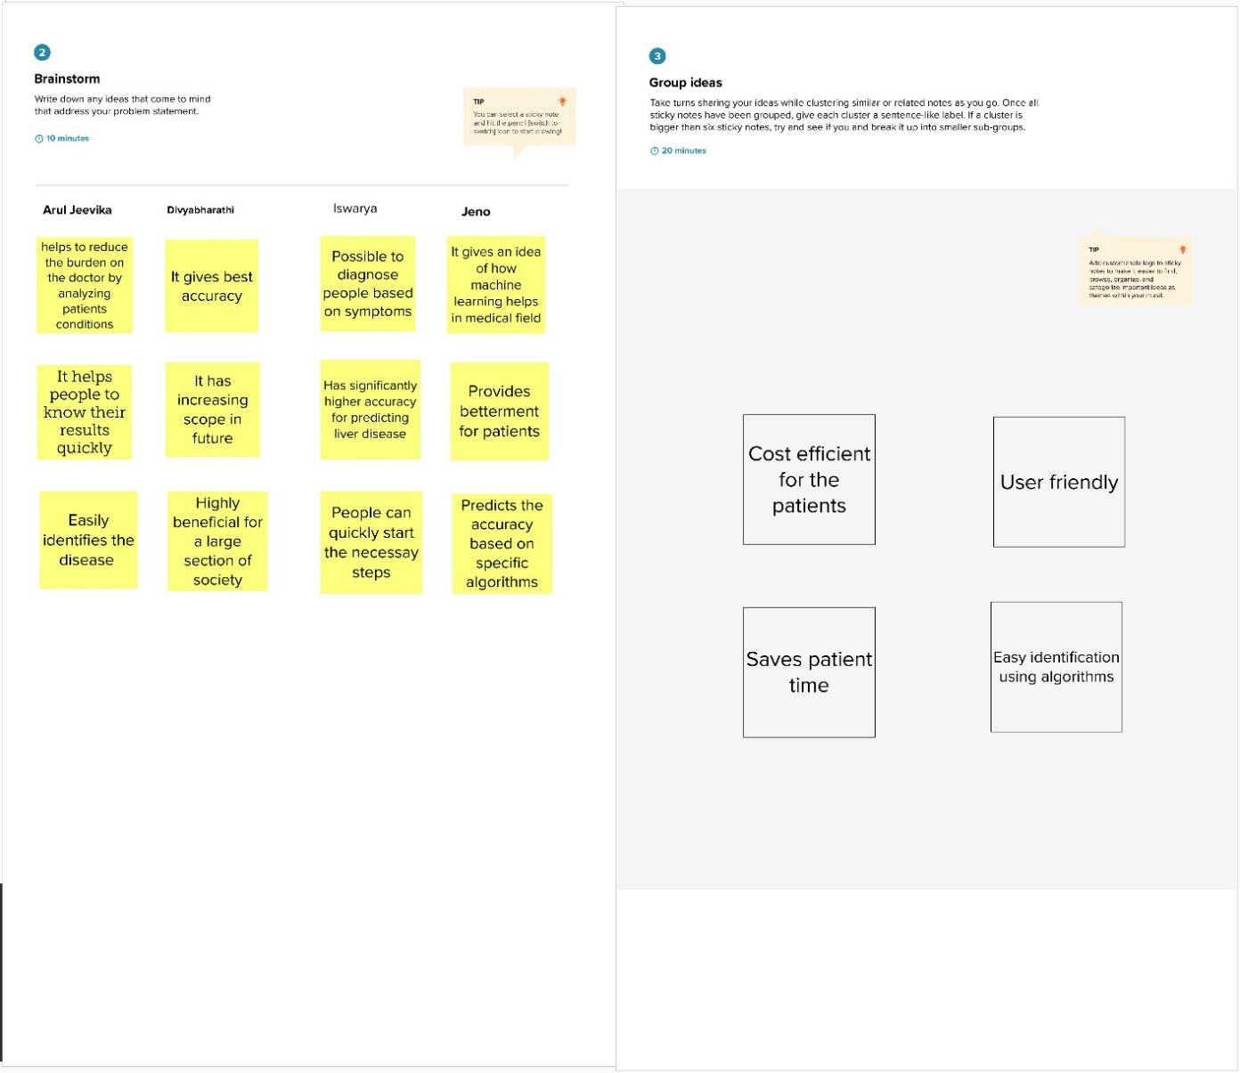

Step-3: Idea Prioritization

